3KEB - Cycle

Functionality
Assessment of relevant overhead costs is performed at period closing (actual data) or plan closing (plan data). The values of head office/admin profit center that are not related to a product group will be allocated to the product group profit centers in order to have a complete income statement by product by company code.
Allocations of cost and revenues (Assessments) will only take place in Profit Center Accounting where they cannot be carried out in Controlling.

Scenario
Assess other profit center (7000) costs to some of the product profit centers according to a fixed percentage amount.

Requirements

Plan assessment cycle must be prepared. Master data used in the assessment cycle must be maintained, i.e. assessment secondary cost element (category 42).

Menu Path | SAP menu → Accounting → Controlling → Profit Center Accounting → Planning → Plan Allocations → 3KEB - Assessment
Transaction Code | 3KEB

1. Double Click on 3KEB - Assessment

Execute Plan Assessment: Initial Screen

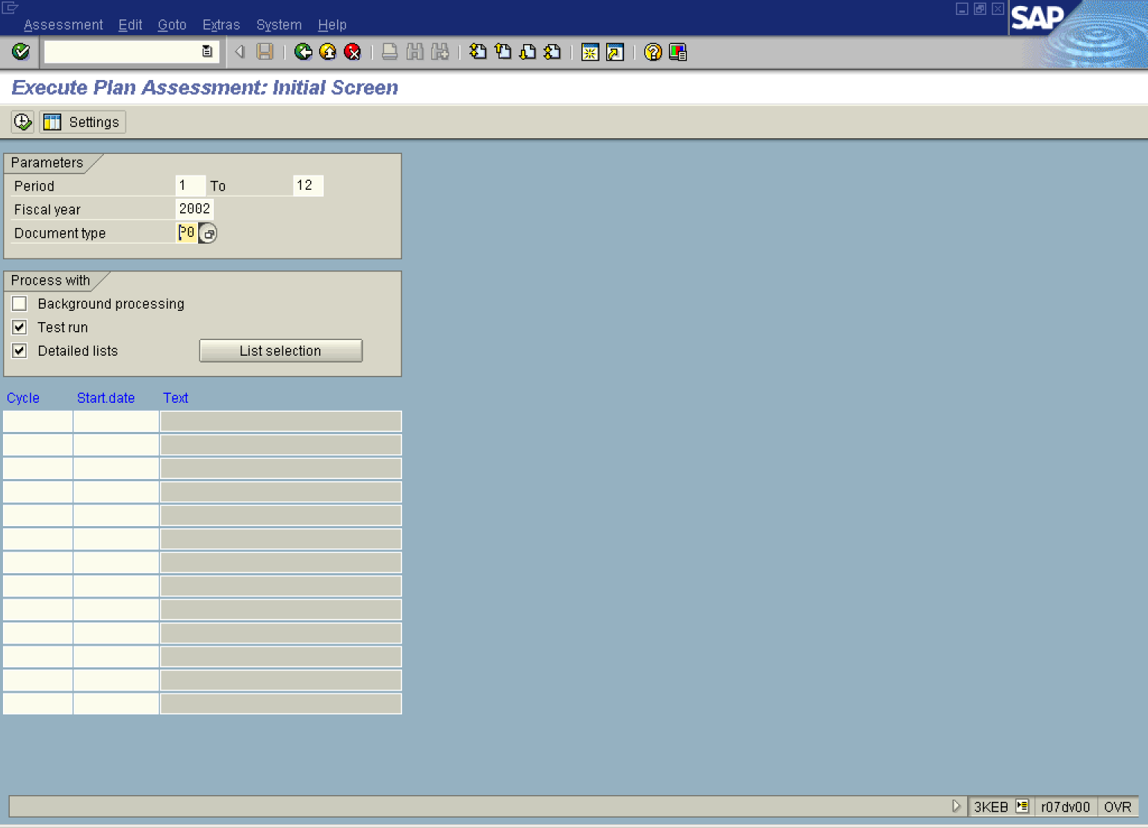

2. Update the following fields:

Field Name | Field Description | Values
Period | From period | Example: 1
To | To Period | Example: 12
Fiscal year | Description of the relevant Fiscal year. | Example: 2002
Document type | Relevant document type for planning in PCA | Example: P0
Cycle | Relevant name of a cycle | Example: 52GA1P

Execute Plan Assessment: Initial Screen

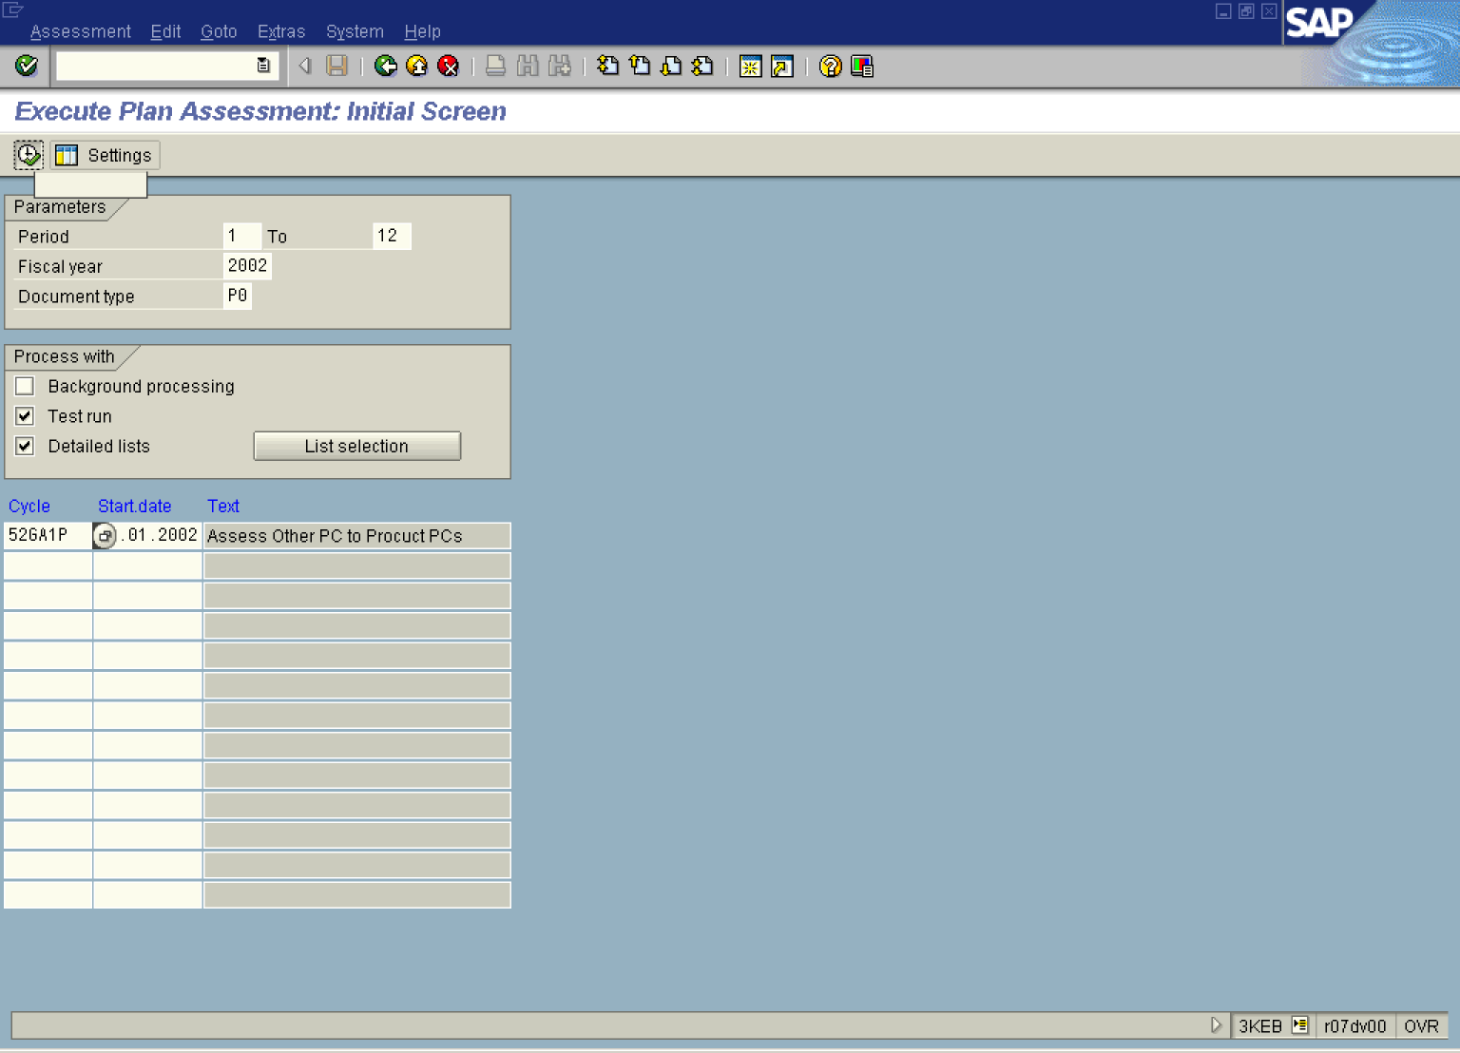

3. Click Test run .

4. Click Detailed lists .

5. Click .

Display EC-PCA: Plan Assessment Basic list

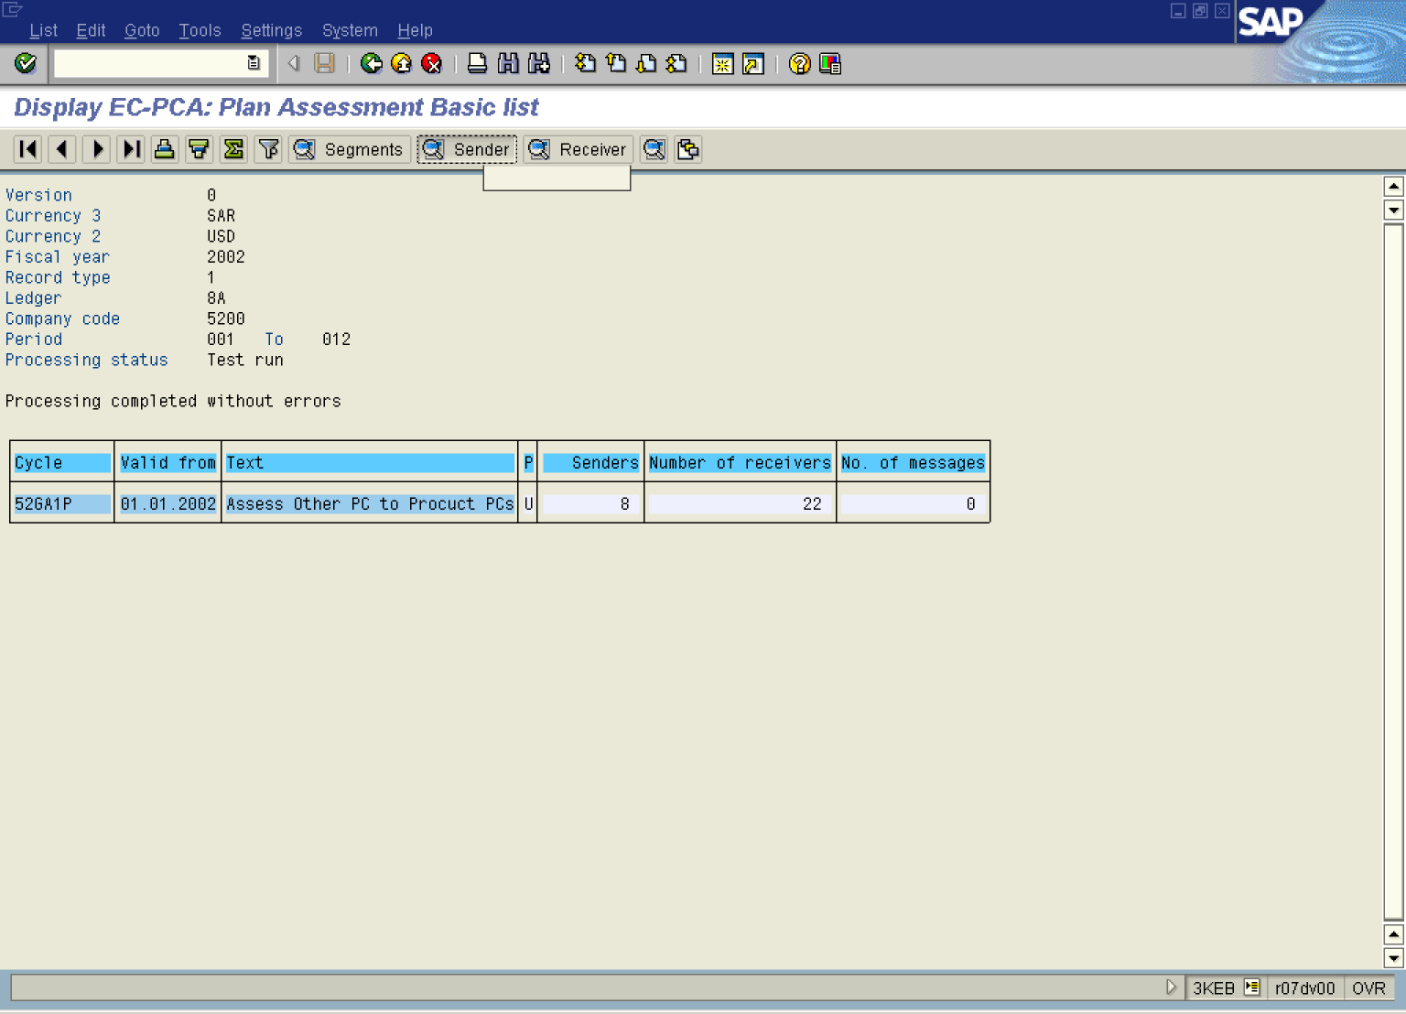

6. Click 8 .

7. Click Sender Button .

Display EC-PCA: Plan Assessment Sender list

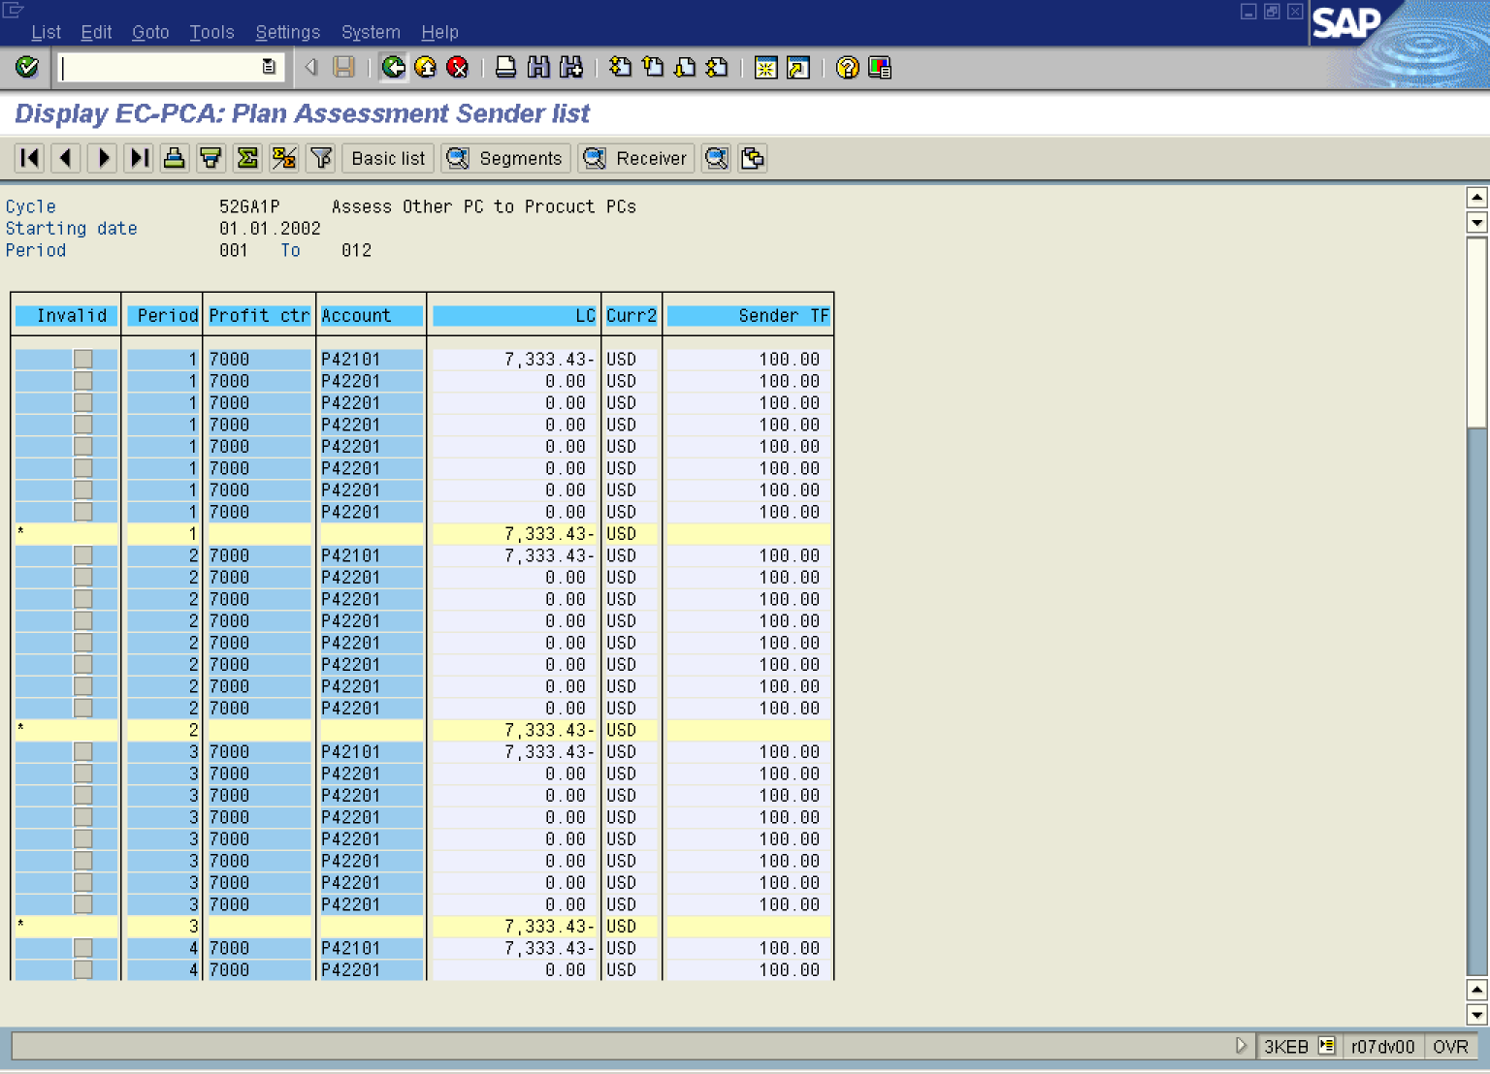

8. Click Back .

Display EC-PCA: Plan Assessment Basic list

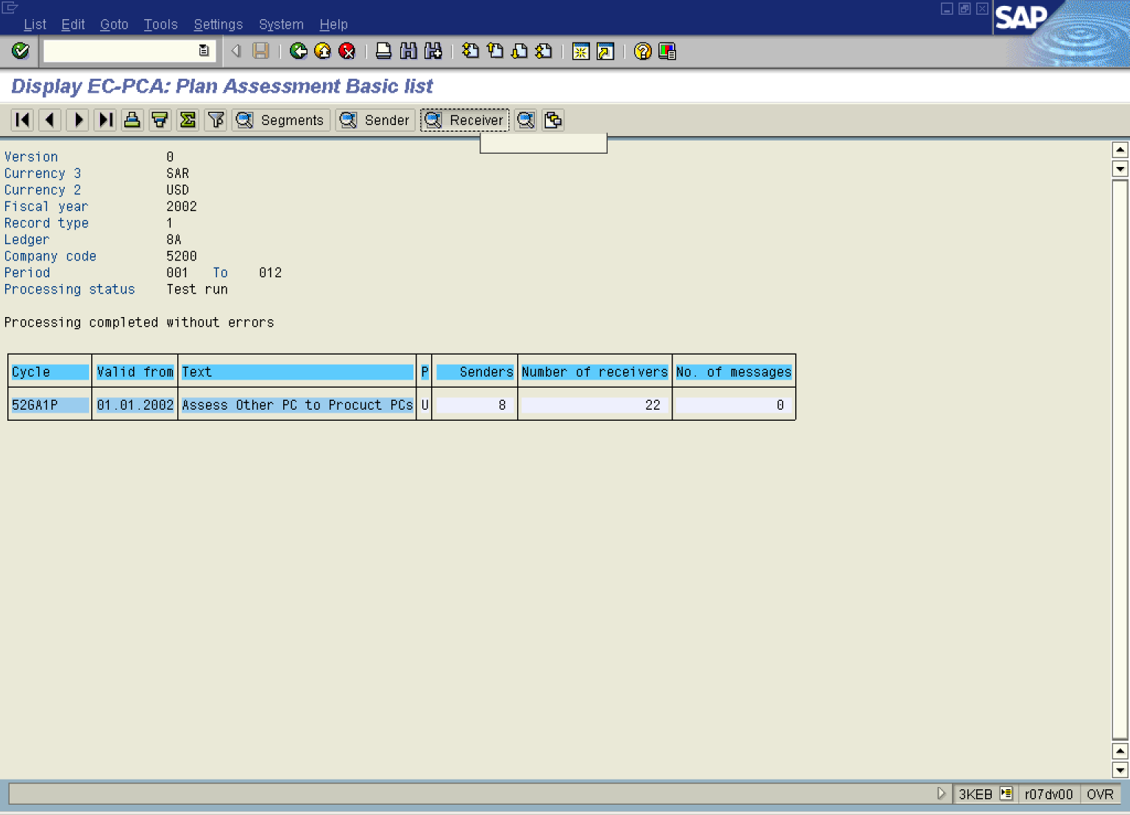

9. Click Receiver Button .

Display EC-PCA: Plan Assessment Receiver list

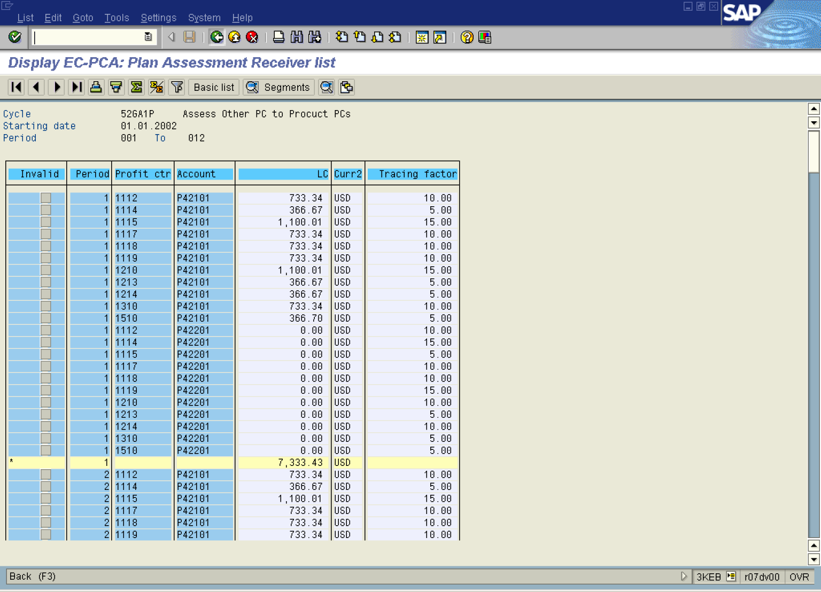

10. Click Back .

Display EC-PCA: Plan Assessment Basic list

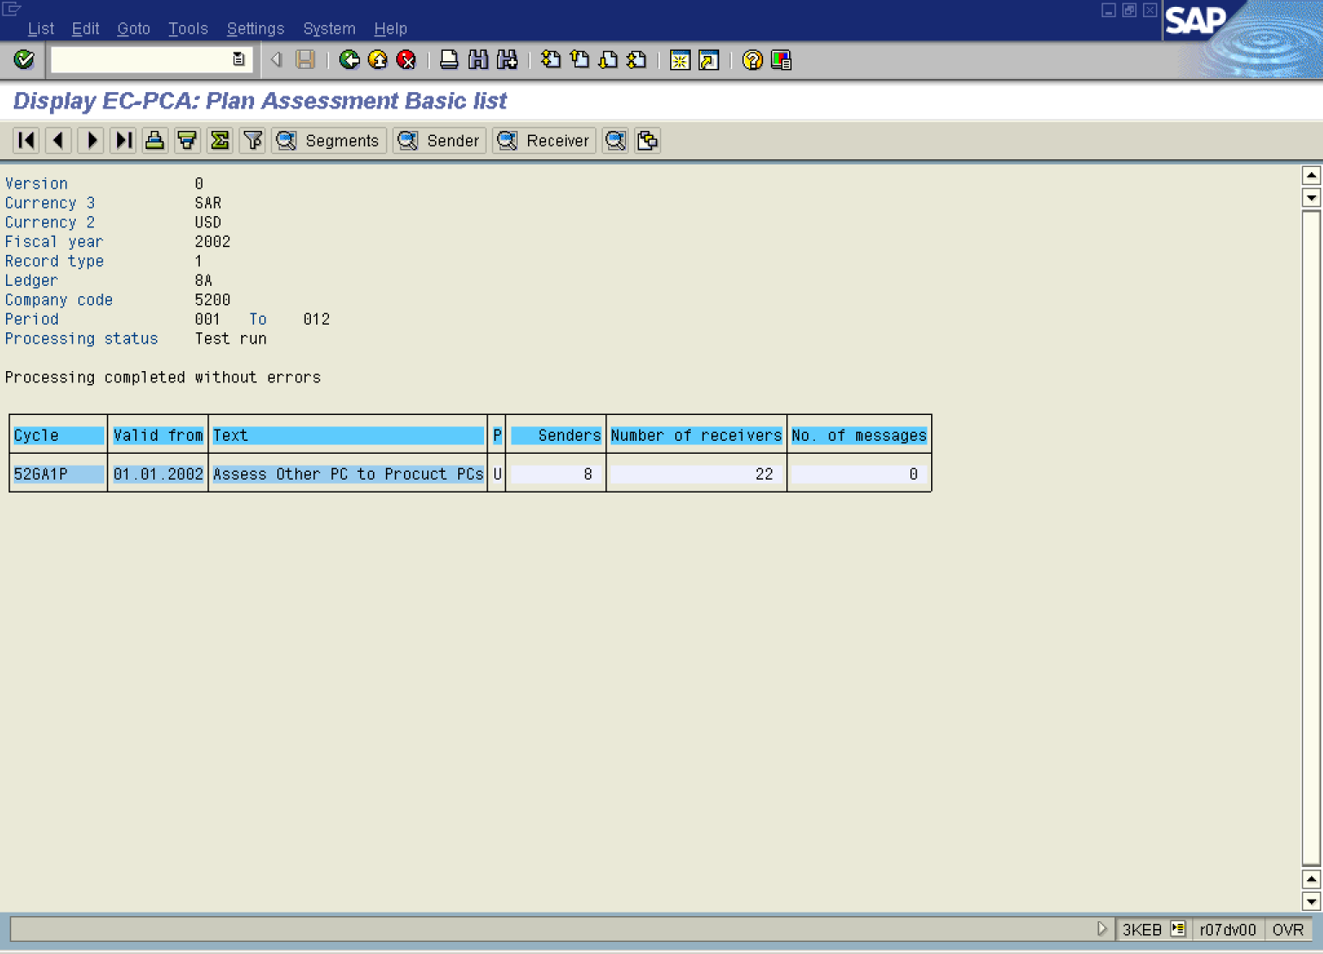

11. Select GotoMessa gesTotal.

Display EC-PCA: Plan Assessment Basic list

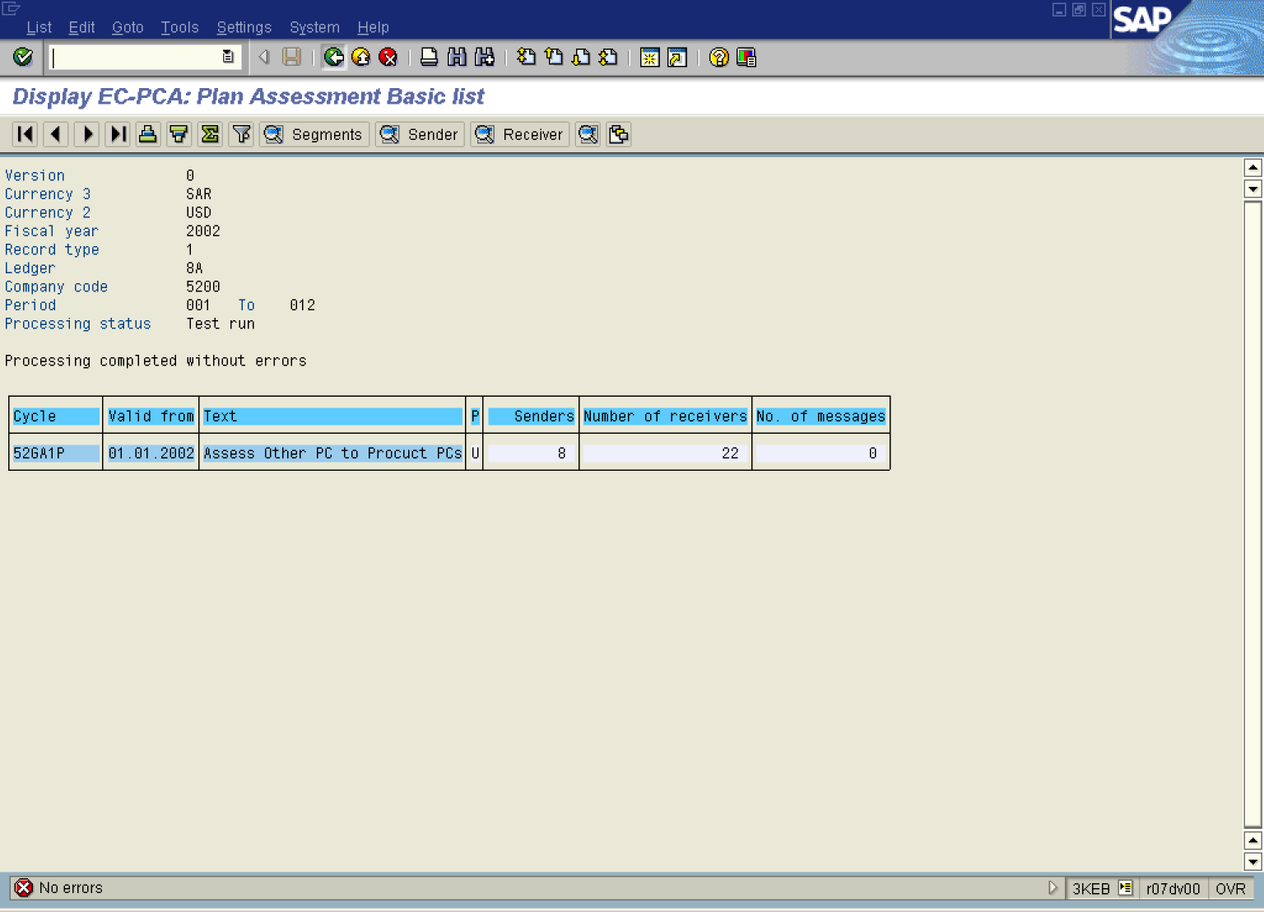

12. The message bar displays “No errors”.

Execute Plan Assessment: Initial Screen

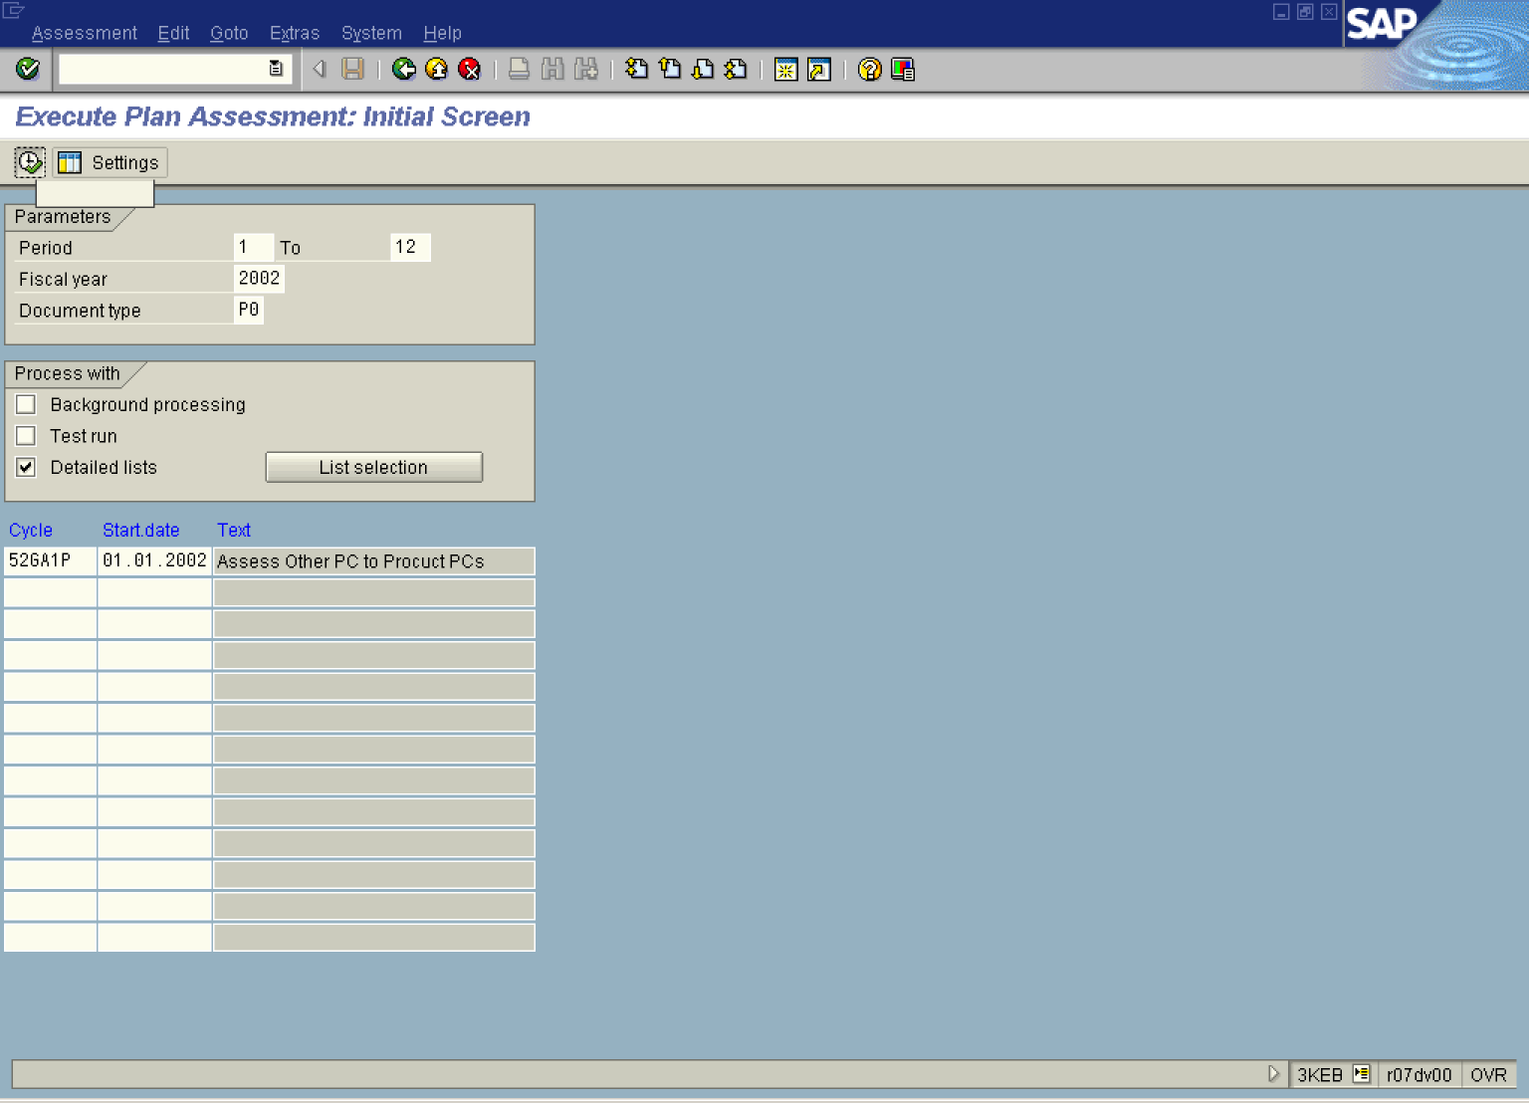

13. Click Test run to unmark

14. Click .

Display EC-PCA: Plan Assessment Basic list

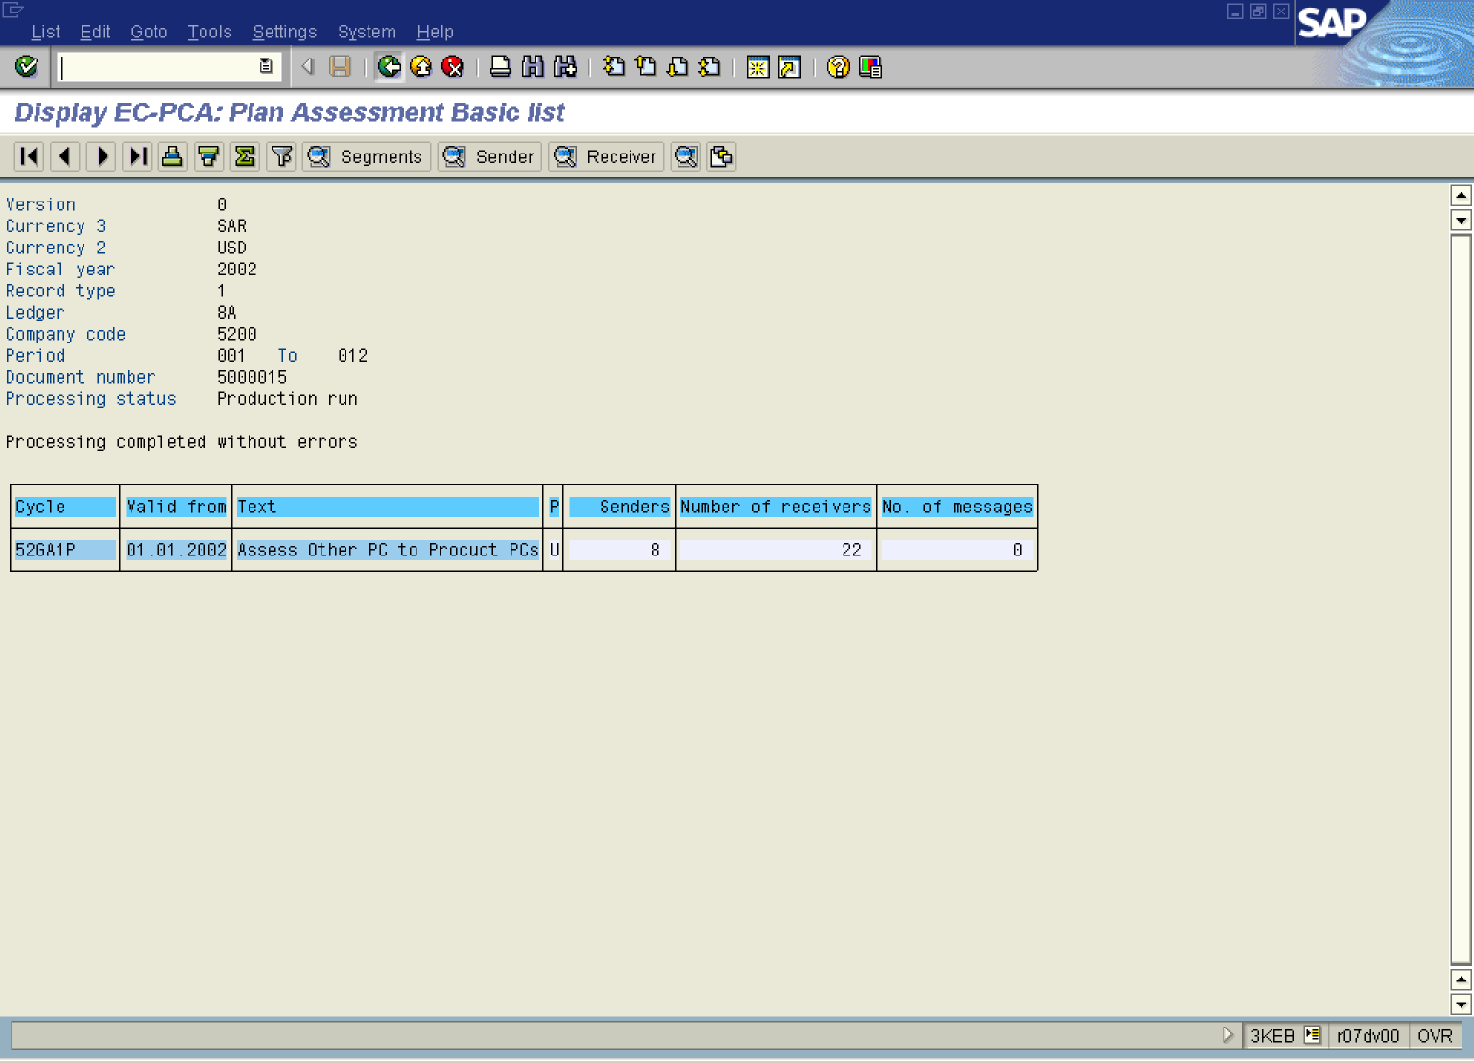

15. Click Back .

Exit list

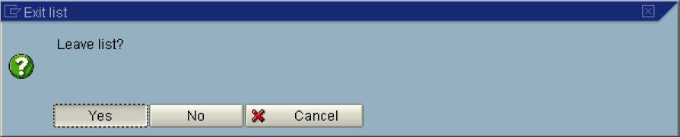

16. Click Yes Button .

Execute Plan Assessment: Initial Screen

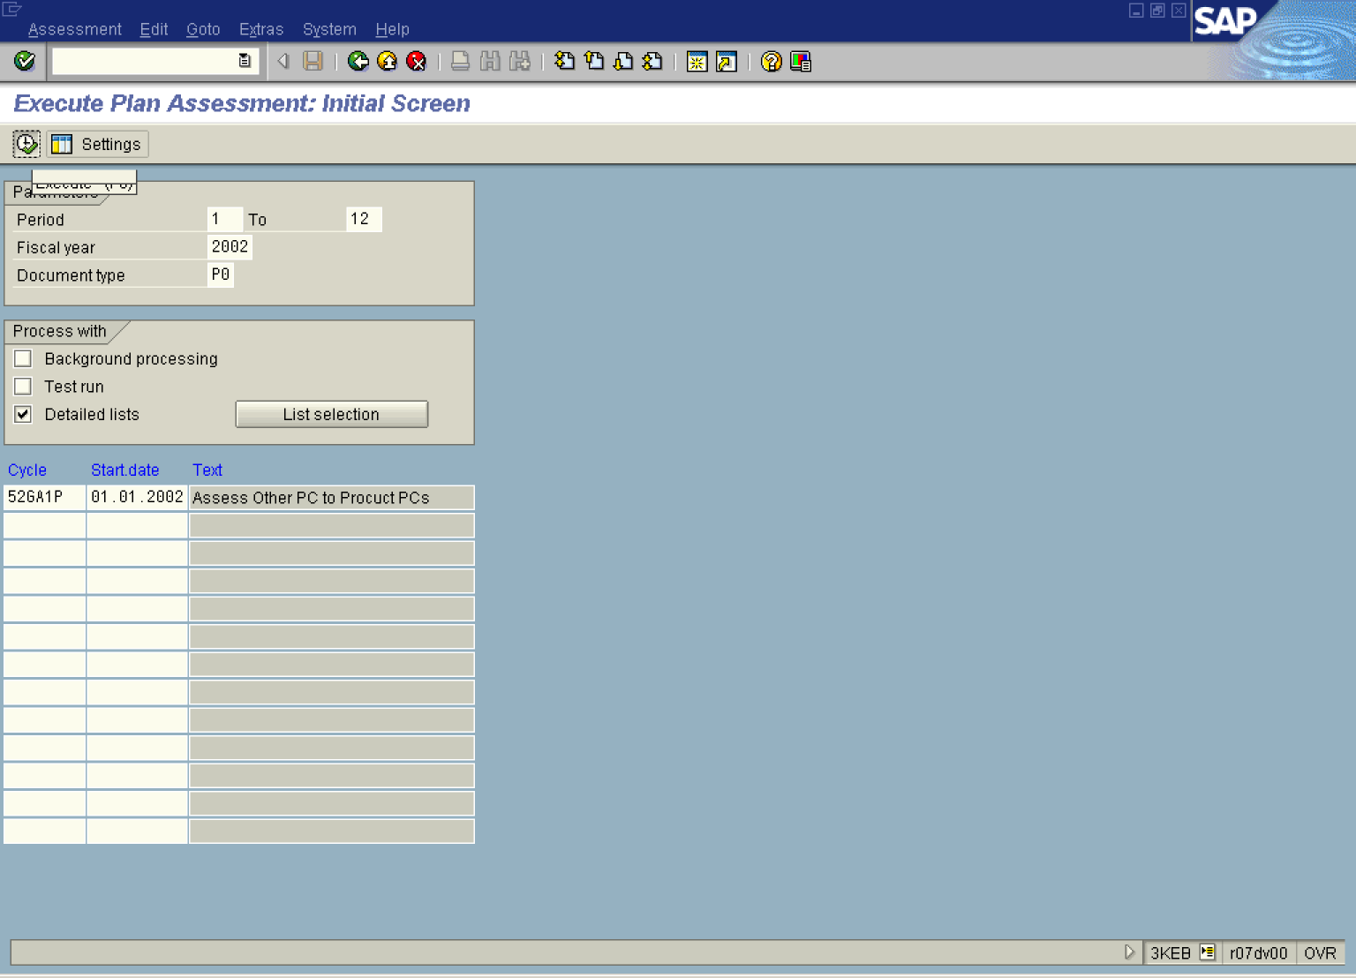

Reverse Plan Assessment: Initial Screen

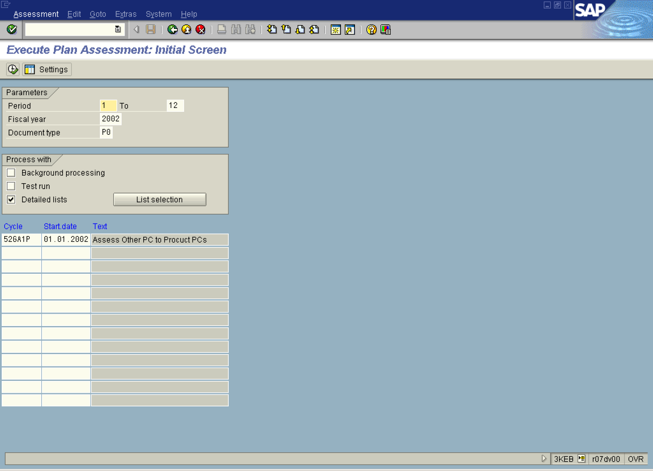

17. From the SAP main menu, use the following menu path: AssessmentReverse.

Information

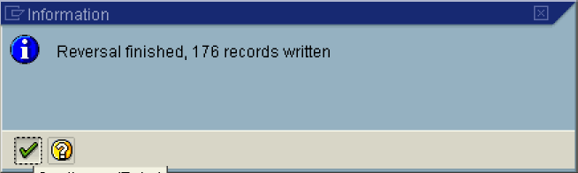

18. Click .

Execute Plan Assessment: Initial Screen

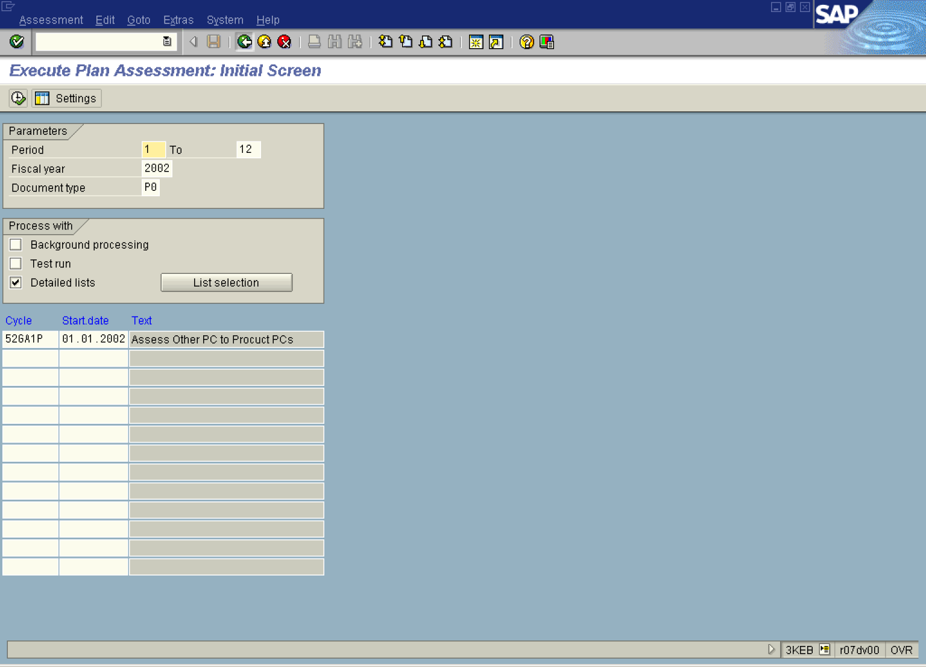

19. Click Back .

